**METHODS de STRINGS**

[chuleta](https://www.w3schools.com/python/python_ref_string.asp) de internet

→ python_string_operations

[lesson del profe](https://drive.google.com/drive/folders/16i3adHMdlHJQNJKTi2-i7E3jgKho-SOO)

Python es un lenguaje de programación orientado a objetos (instancias de clases con methods)

* **+** operator concatenates two strings together

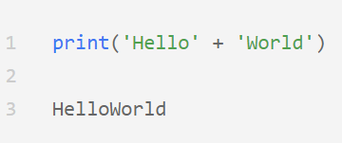

* **\*** operator repeats a string a given number of times

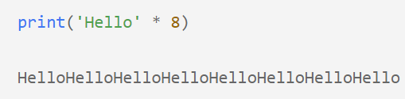

* **.join()** UNE strings de una LISTA o de un STRING. UNE, podemos poner espacios o lo que queramos dentro de ese string “putos”.join(z) → happyputospuppies

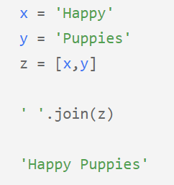 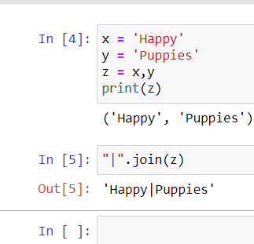

* **.length()** of strings

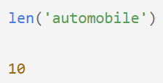

* subset (dividir) string via **indexing**:

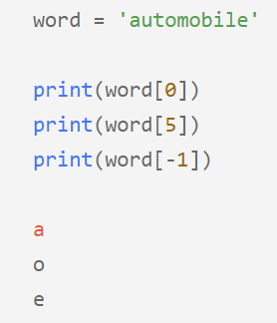

* use the **.split()** method to **turn strings into lists** based on a separator that we designate

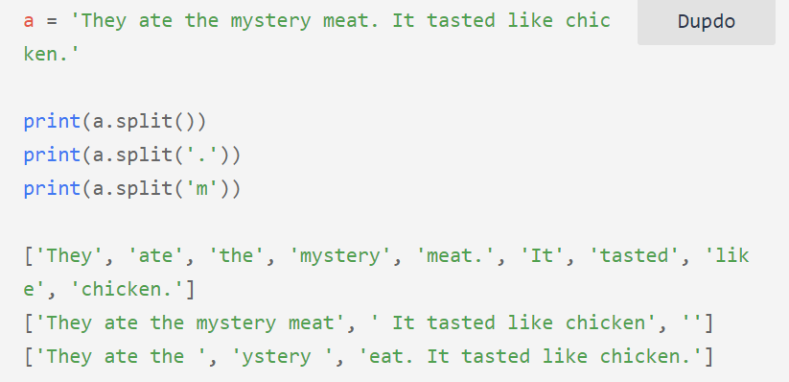

* **.startswith()** → variable/string empieza por

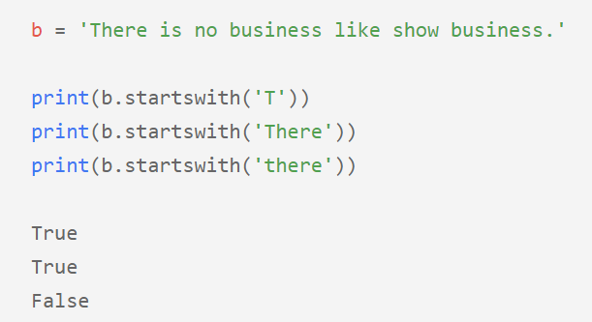

* **.endswith()** → variable/string termina por

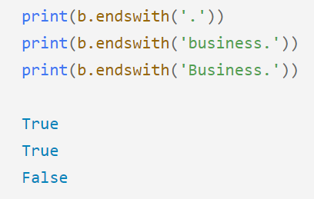

* **in** → variable/string contiene por

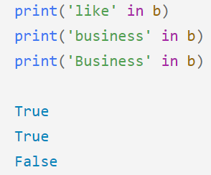

* **#** → comenta la línea
* **“””** al principio y **“””** al final comenta tas las líneas que hay dentro
* **.format()** → Formats specified values in a string

a= “hola”

b = “que tal”

print(“**{}** alvaro **{}** estas”**.format(a,b)**)

→ hola alvaro que tal estas

or

print(“**{0}** alvaro **{1}** estas, **{0}**”.format(a,b))

→ hola alvaro que tal estas, hola

print(f”**{a}** alvaro **{b}**”)

→ hola alvaro que tal estas

* **.strip()** → quita espacios al principio y al final
* **.lstrip()** → quita espacios al principio (left)
* **.rstrip()** → quita espacios al final (right)

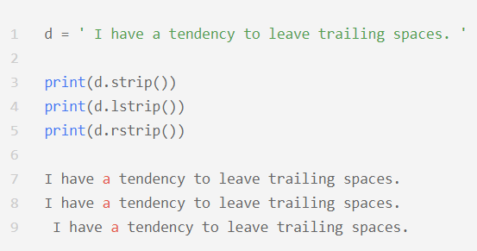

* **.lower()** → todo a minúscula
* **.upper()** → todo a mayúscula
* **.capitalize()** → solo la primera palabra
* **.title()** → la primera letra de cada palabra

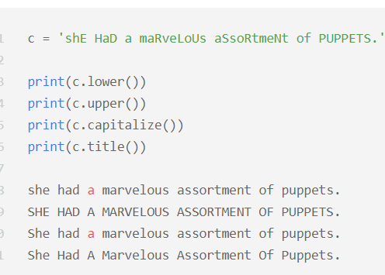

* **.replace(“a eliminar”,”a incluir”)** → reemplaza un string por otro

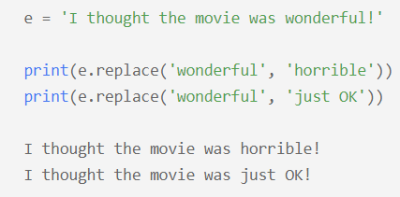

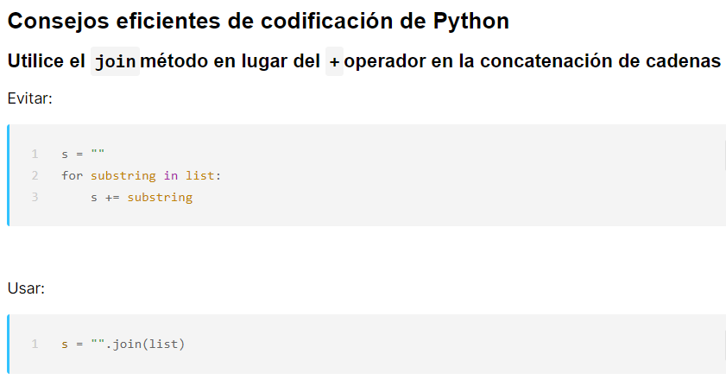

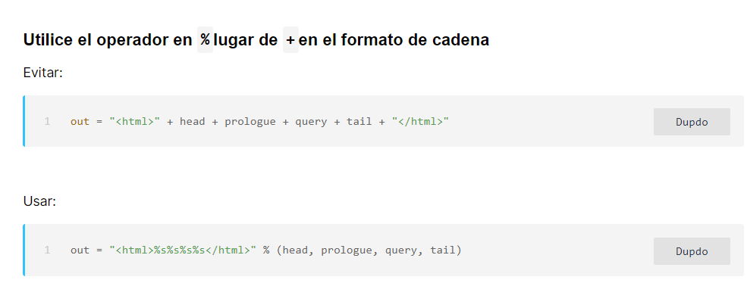

# [Python String Methods](https://www.w3schools.com/python/python_ref_string.asp)

| **Method** | **Description** |
| --- | --- |
| [capitalize()](https://www.w3schools.com/python/ref_string_capitalize.asp) | Converts the first character to upper case |
| [casefold()](https://www.w3schools.com/python/ref_string_casefold.asp) | Converts string into lower case |
| [center()](https://www.w3schools.com/python/ref_string_center.asp) | Returns a centered string |
| [count()](https://www.w3schools.com/python/ref_string_count.asp) | Returns the number of times a specified value occurs in a string |
| [encode()](https://www.w3schools.com/python/ref_string_encode.asp) | Returns an encoded version of the string |
| [endswith()](https://www.w3schools.com/python/ref_string_endswith.asp) | Returns true if the string ends with the specified value |
| [expandtabs()](https://www.w3schools.com/python/ref_string_expandtabs.asp) | Sets the tab size of the string |
| [find()](https://www.w3schools.com/python/ref_string_find.asp) | Searches the string for a specified value and returns the position of where it was found |
| [format()](https://www.w3schools.com/python/ref_string_format.asp) | Formats specified values in a string |
| format_map() | Formats specified values in a string |
| [index()](https://www.w3schools.com/python/ref_string_index.asp) | Searches the string for a specified value and returns the position of where it was found |
| [isalnum()](https://www.w3schools.com/python/ref_string_isalnum.asp) | Returns True if all characters in the string are alphanumeric |
| [isalpha()](https://www.w3schools.com/python/ref_string_isalpha.asp) | Returns True if all characters in the string are in the alphabet |
| [isascii()](https://www.w3schools.com/python/ref_string_isascii.asp) | Returns True if all characters in the string are ascii characters |
| [isdecimal()](https://www.w3schools.com/python/ref_string_isdecimal.asp) | Returns True if all characters in the string are decimals |
| [isdigit()](https://www.w3schools.com/python/ref_string_isdigit.asp) | Returns True if all characters in the string are digits |
| [isidentifier()](https://www.w3schools.com/python/ref_string_isidentifier.asp) | Returns True if the string is an identifier |
| [islower()](https://www.w3schools.com/python/ref_string_islower.asp) | Returns True if all characters in the string are lower case |
| [isnumeric()](https://www.w3schools.com/python/ref_string_isnumeric.asp) | Returns True if all characters in the string are numeric |
| [isprintable()](https://www.w3schools.com/python/ref_string_isprintable.asp) | Returns True if all characters in the string are printable |
| [isspace()](https://www.w3schools.com/python/ref_string_isspace.asp) | Returns True if all characters in the string are whitespaces |
| [istitle()](https://www.w3schools.com/python/ref_string_istitle.asp) | Returns True if the string follows the rules of a title |
| [isupper()](https://www.w3schools.com/python/ref_string_isupper.asp) | Returns True if all characters in the string are upper case |
| [join()](https://www.w3schools.com/python/ref_string_join.asp) | Converts the elements of an iterable into a string |
| [ljust()](https://www.w3schools.com/python/ref_string_ljust.asp) | Returns a left justified version of the string |
| [lower()](https://www.w3schools.com/python/ref_string_lower.asp) | Converts a string into lower case |
| [lstrip()](https://www.w3schools.com/python/ref_string_lstrip.asp) | Returns a left trim version of the string |
| [maketrans()](https://www.w3schools.com/python/ref_string_maketrans.asp) | Returns a translation table to be used in translations |
| [partition()](https://www.w3schools.com/python/ref_string_partition.asp) | Returns a tuple where the string is parted into three parts |
| [replace()](https://www.w3schools.com/python/ref_string_replace.asp) | Returns a string where a specified value is replaced with a specified value |
| [rfind()](https://www.w3schools.com/python/ref_string_rfind.asp) | Searches the string for a specified value and returns the last position of where it was found |
| [rindex()](https://www.w3schools.com/python/ref_string_rindex.asp) | Searches the string for a specified value and returns the last position of where it was found |
| [rjust()](https://www.w3schools.com/python/ref_string_rjust.asp) | Returns a right justified version of the string |
| [rpartition()](https://www.w3schools.com/python/ref_string_rpartition.asp) | Returns a tuple where the string is parted into three parts |
| [rsplit()](https://www.w3schools.com/python/ref_string_rsplit.asp) | Splits the string at the specified separator, and returns a list |
| [rstrip()](https://www.w3schools.com/python/ref_string_rstrip.asp) | Returns a right trim version of the string |
| [split()](https://www.w3schools.com/python/ref_string_split.asp) | Splits the string at the specified separator, and returns a list |
| [splitlines()](https://www.w3schools.com/python/ref_string_splitlines.asp) | Splits the string at line breaks and returns a list |
| [startswith()](https://www.w3schools.com/python/ref_string_startswith.asp) | Returns true if the string starts with the specified value |
| [strip()](https://www.w3schools.com/python/ref_string_strip.asp) | Returns a trimmed version of the string |
| [swapcase()](https://www.w3schools.com/python/ref_string_swapcase.asp) | Swaps cases, lower case becomes upper case and vice versa |
| [title()](https://www.w3schools.com/python/ref_string_title.asp) | Converts the first character of each word to upper case |
| [translate()](https://www.w3schools.com/python/ref_string_translate.asp) | Returns a translated string |
| [upper()](https://www.w3schools.com/python/ref_string_upper.asp) | Converts a string into upper case |
| [zfill()](https://www.w3schools.com/python/ref_string_zfill.asp) | Fills the string with a specified number of 0 values at the beginning |